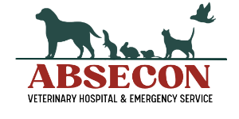
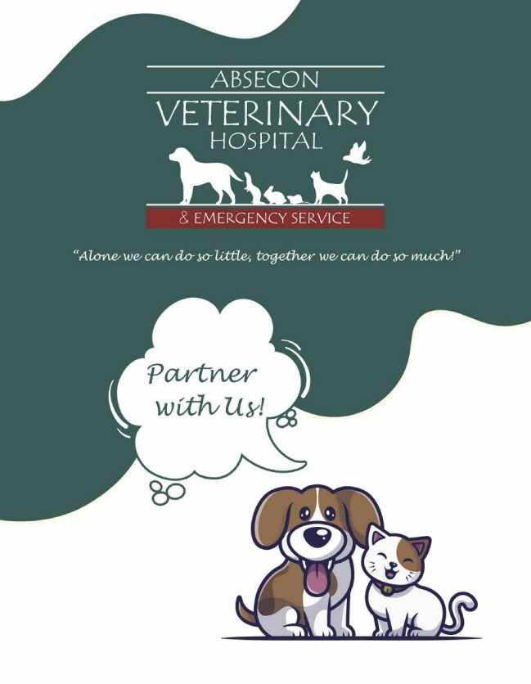
Absecon Veterinary Hospital provides General Practice and Emergency Services with 20+ doctors and 80+ support staff (including Exotic Specialties). Currently, we are open 8 am-10 pm with 24-hour nursing support 7 days per week.
We are thrilled to welcome your organization to Absecon Veterinary Hospital’s Rescue Partnership Program! Partnering with us incentivizes you with a 25% discount off all services, prescriptions, products, as well as formal partnership promotion of your rescue on our hospital’s website.
Once the required documentation listed below is submitted and reviewed, your organization will begin receiving your discount as outlined.
*Note: There is a 30-day account processing period where the discounts do not apply. Rescues may use our services during that period, but the discount will not apply until the 31st day.
We have so much to offer! Thank you for entrusting Absecon Veterinary Hospital with the care of your rescue pets, we look forward to a long and meaningful partnership!
Our Rescue Coordinator and Financial Specialist are available to help with questions, concerns, marketing, and foster/adoption resources. Please contact:

Cherie Scheurich Linda DePicciotto
Hospital Administrator & Financial Specialist
Rescue Coordinator ldepicciotto@abseconvet.com
cscheurich@abseconvet.com 609-646-7013 ext 172
609-646-7013 ext 127
Cell 609-929-6907

THANK YOU FOR BEING A PARTNER

Now you can take advantage of these special benefits:
Spay & Neuter Program
We offer special pricing for rescues as well as a discounted program for your adopters.
For Rescues:
Spay & Neuter Program
 | Canine | Total Price | Rescue Price | Adopter Price
Female | Under 1 Year  Over 1 Year  Over 75 Lbs | $250.00  $330  Add $40 | $105.00 | $145.00  $225.00  Add $40
Male | Under 1 Year  Over 1 Year  Over 75 Lbs | $220.00  $300.00  Add $40 | $80.00 | $140.00  $220.00  Add $40
 | Feline | Total Price | Rescue Price | Adopter Price
Female | Under 1 Year  Over 1 Year | $245.00  $260.00 | $100.00 | $145.00  $160.00
Male | Under 1 Year  Over 1 Year | $130.00  $180.00 | $60.00 | $70.00  $120.00

These are reduced prices for rescues. The rescue ONLY pays the cost in yellow. The Adopter Price includes Pre-Op bloodwork, take-home medications, and an e-collar. The adopter’s costs are a bundled item and cannot be broken up. The adopter price does NOT cover exam fee and pre-sx meds.
If there is no adopter at the time of spay/neuter, the rescue would pay the “Total Price.”

PARTNERSHIP
We strongly believe in giving back to the community and supporting the efforts of local animal rescues and shelters! We are open to any and all ideas to find these wonderful pets their forever home as well as keeping them safe and healthy. We are honored to contribute to your purpose in any way that we can. For event collaboration/sponsorships, please don’t hesitate to call, text, or email me.
Cherie
cscheurich@abseconvet.com
609-646-7013/ext 127
Cell 609-929-6907

Document Checklist

Please provide the following:

- Copy of 501c3
- Email address
- Phone numbers & address
- Donation Agreement
- 2 Organization contacts
- Description of the animals your rescue serves
- Payment Options Agreement

________________________ ____________________________ ___________________ __________________
President’s Name Address Phone Email

________________________ ____________________________ ___________________ __________________
Vice President’s Name Address Phone Email

AVH Adoption Network

As an extra perk for partnering with us, we can help you canvas for Pet Foster Parents and advertise some of your adoptable pets on social media and in our Client Monthly Newsletter. We encourage you to contact Cherie before the 20th of each month with pictures and bios of pets you would like AVH to promote for adoption or foster.
We have a nonprofit organization (Vet Bill Assistance Program) that holds a large annual fundraiser called Bark in the Park in the fall each year. Rescue Partners are invited to have a booth at this event free of charge to collect donations, canvas for fosters, and advertise your adoptable pets.
In addition, $50 Off First Exam Coupons will be mailed to you to distribute to adopting families who reside in our local area.

Credit Card Authorization

First Name: ______________________________ Phone: ______________________________
Last Name: ______________________________ Email: _______________________________
Rescue Name: ___________________________ Card Type: __________________________
Address: _________________________________ Cardholder Name: __________________
City: _____________________________________ Expiration Date: _____________________
State & Zip: ______________________________ Security Code: ______________________

I, ________________________________________, authorize Absecon Veterinary Hospital to charge my credit card for agreed upon purchases. I understand that my information will be saved on file for future transactions on my account.
Signature: ________________________________ Date: _______________________________
Please list the population your rescue serves and anything special you would like us to know and/or advertise:

Dear New Rescue Partner,
There’s much to do with regard to rescues, and we know how hard you all work to ensure the care, safety, transport, and well-being of all the animals in your organization. The work you do is very important to us, and we whole-heartedly believe that Together We Make a Difference!
Therefore, in an attempt to streamline some billing and payment processing issues that often take up a great deal of time for both of us. We want to develop a system that works best for you on a monthly basis. Below are a few options to consider. Please review each option and choose which one will work best for your organization. Choose one below:

- _____ We prefer to pay our bill in full monthly. AVH may bill my credit card on the first Friday of each month.

- _____ We prefer to pay our bill in payment installments of 50% of your account balance each month. AVH may bill my credit card on the first Friday of each month.

- _____ We prefer to send in our payment in full or in payment installments of 50% of your account balance via check after I receive my monthly invoice (at the end of the month). I will mail in my check by the first Friday of each month.

If you require any other payment options or if you are not able to make a payment in a specific month, please reach out to Linda (ext 172), who is now in charge of billing or call me directly (ext 127). As always, don’t hesitate to call or email with your rescue needs, questions, or concerns. We are always here to help! If we do not receive any payments or communications for two consecutive months, AVH will be forced to charge your credit card on file in full.
Thank you for your attention in this matter.
Sincerely,

Cherie & Linda

